Project Modules Implementation

Infrastructure as Code (IaC) Implementation

What this module will do:
- Load Terraform files (.tf) before they are deployed.
- Detect simple misconfigurations like:
Action = "*" or Resource = "*" in IAM policy blocks.
Public S3 buckets (acl = "public-read" or public = true).
Security group with wide-open ingress (0.0.0.0/0).
- Save findings to a CSV/print them on screen.

Steps to reproduce implementation:
Step 1: Install a parser library for HCL (Terraform Language). HCL is a language used to describe infrastructure resources in machine friendly and human-readable format.
Terraform is an open-source IaC tool that uses HCL to define, provision and manage infrastructure resources such as cloud infrastructure in AWS using configuration files. (In short, a CLI for defining resources in cloud instead of clicking buttons).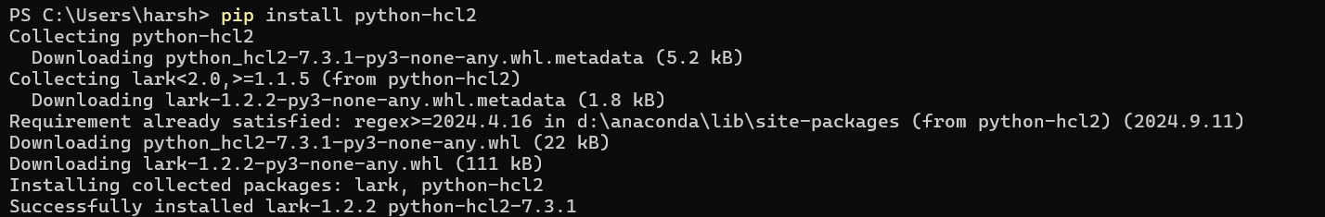

Step 2: Write the python code for the scanner which detects and prevents insecure policies before deployment.
Lets name the file iac_monitor.py:

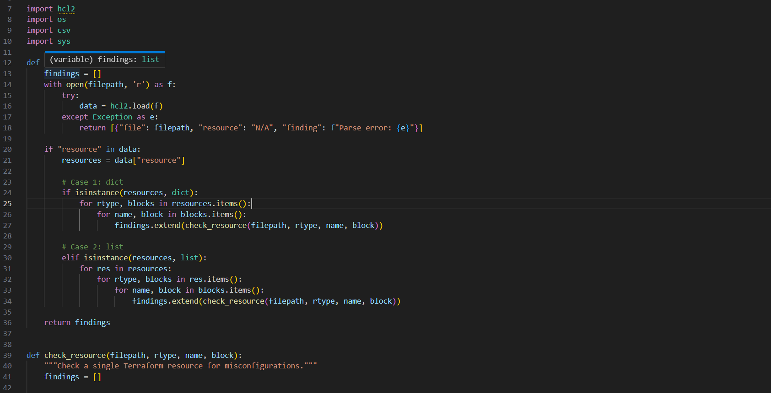
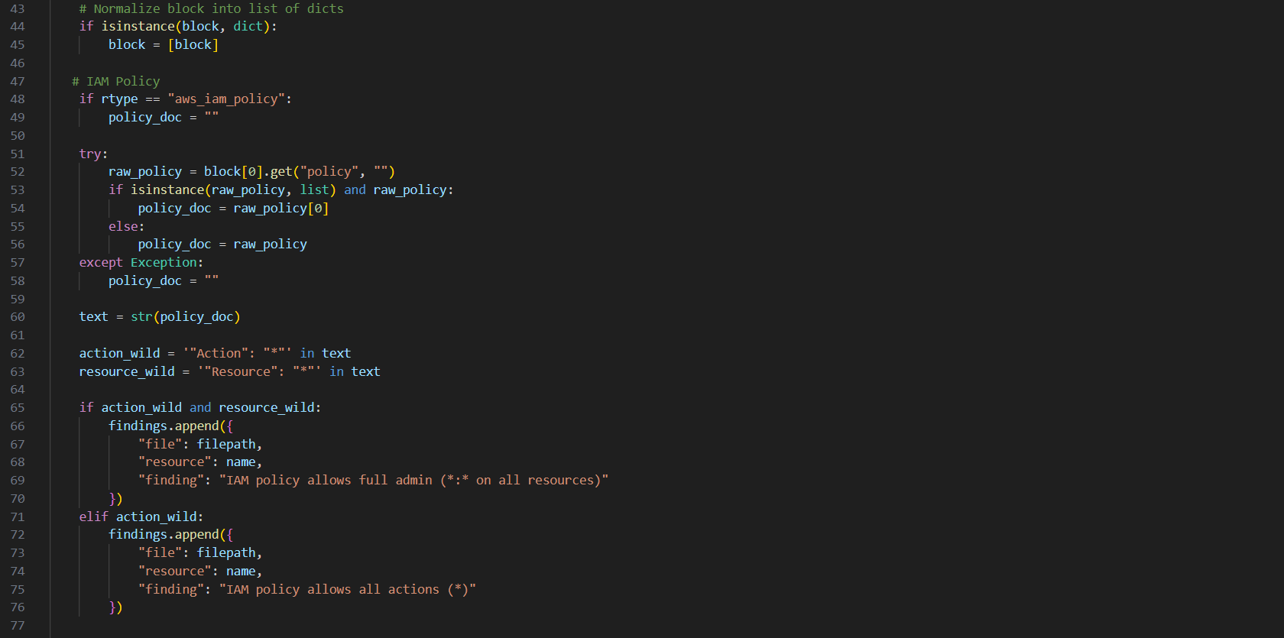
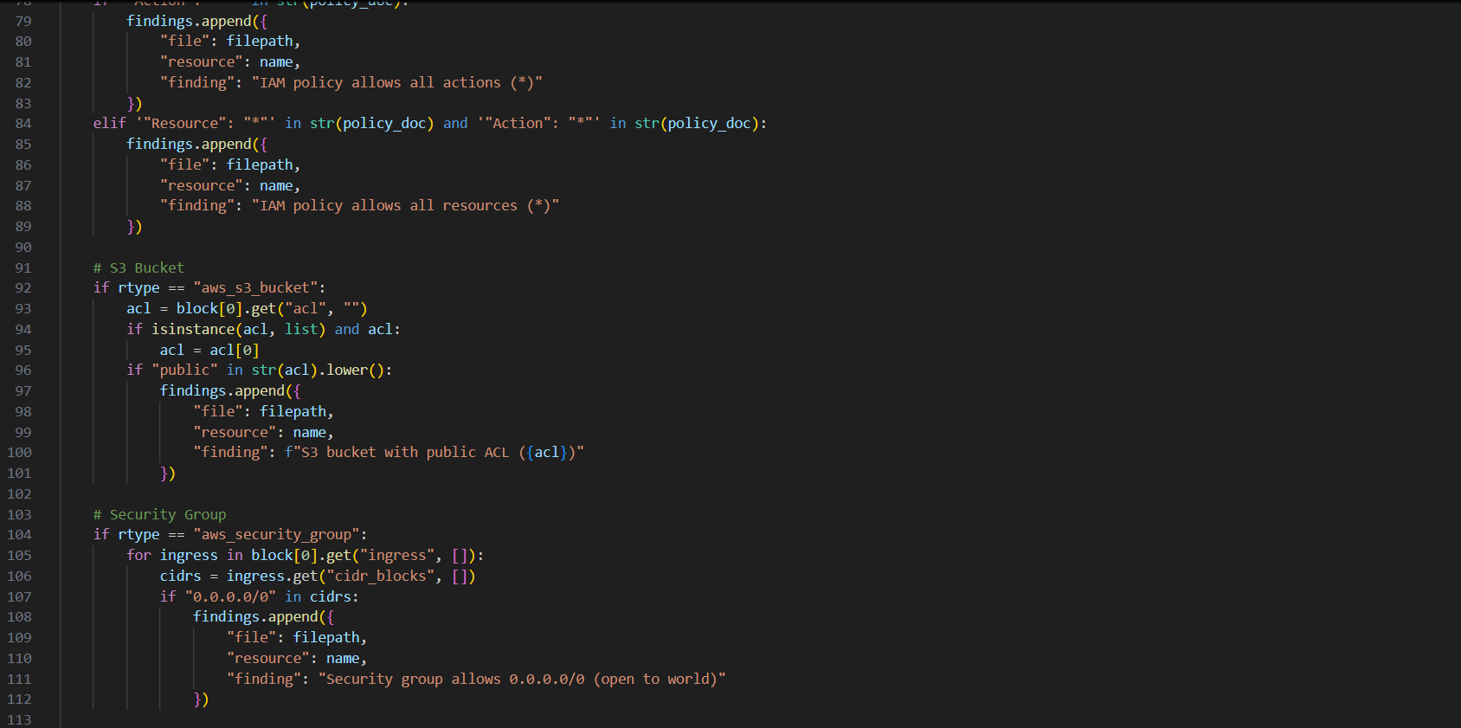
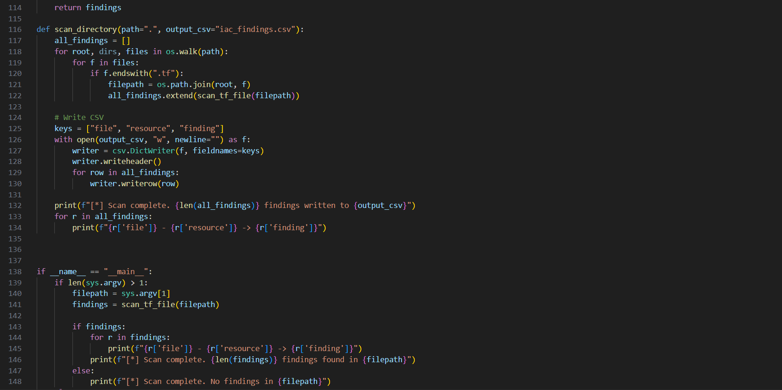
Step 3: We will create three Terraform files to check the scanner’s efficiency and ability to identify misconfigurations.
bad.tf:
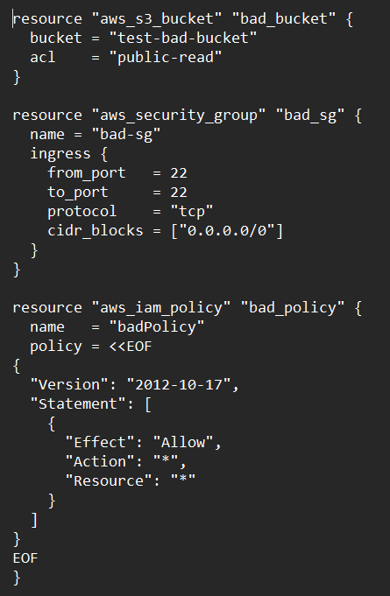

good.tf
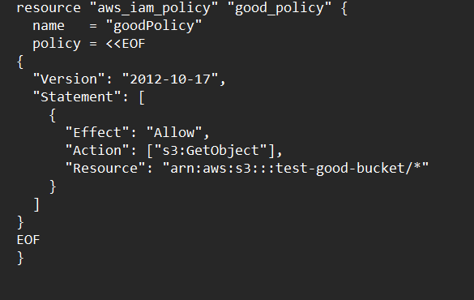
mix.tf
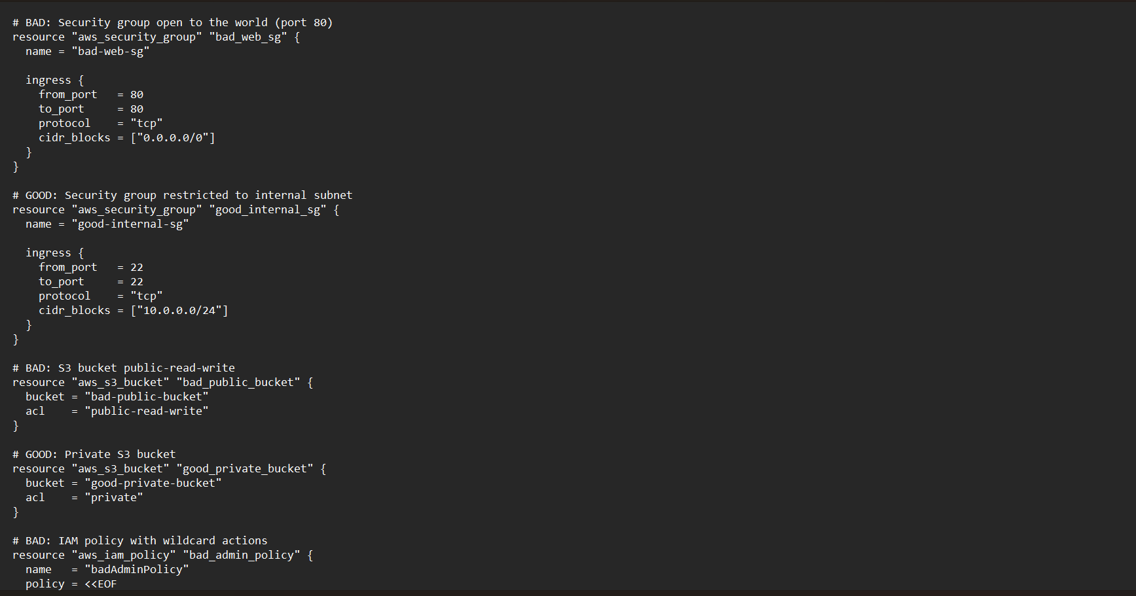
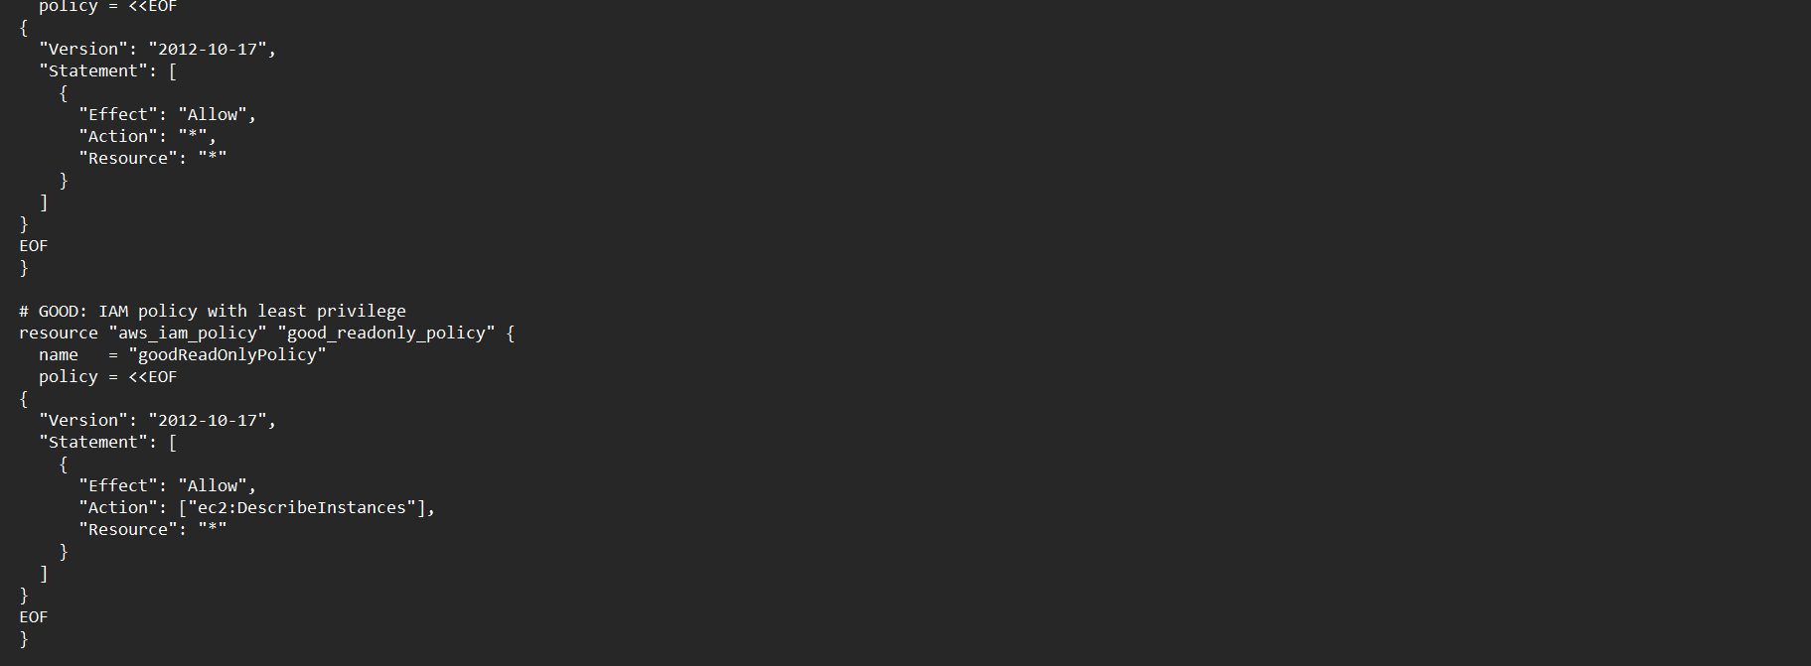

Step 4: Run the scanner against these .tf files and we can see the findings and vulnerabilities detected in the infrastructure of the resource.
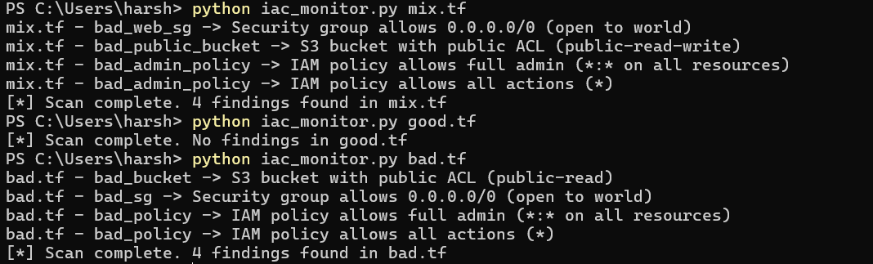

Step 5: The findings are documented in the iac_findings.csv file which can be used to analyze and visualize (using Grafana).
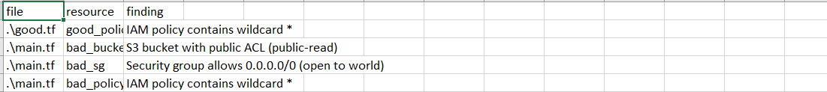

Future Scope:
1. Multi-Cloud Expansion: (Azure, GCP etc).
2. Severity-Based Risk Scoring: High, Medium, Low.
3. Continuous Monitoring: Deploy as a Lambda function to automatically run on a schedule.
4. Visualization & Reporting: Dashboards using AWS QuickSight, Grafana.

Policy Decision Point (PDP)

The Policy Decision Point (PDP):
- Receives access or configuration evaluation requests.
- Applies defined Zero Trust policies (least privilege, deny by default).
- Returns a decision: ALLOW / DENY / REVIEW.

Implementation Steps:
1. Reads input context (user, action, resource, risk level).
2. Applies a set of policies defined in a JSON file.
3. Decides whether to allow or deny access.
4. Logs the decision to a .csv file for review.

Step 1:
Define the policies.json which will simulate the user resource request.
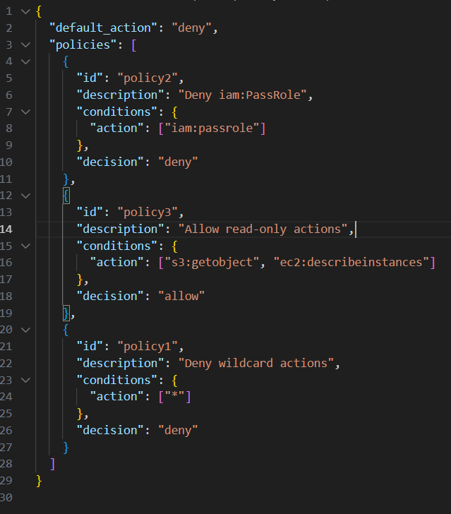
Step 2:
Implement the Policy Decision Point which will read the policies.json file based on actions and also use context awareness to decide whether the request should be accepted or denied.
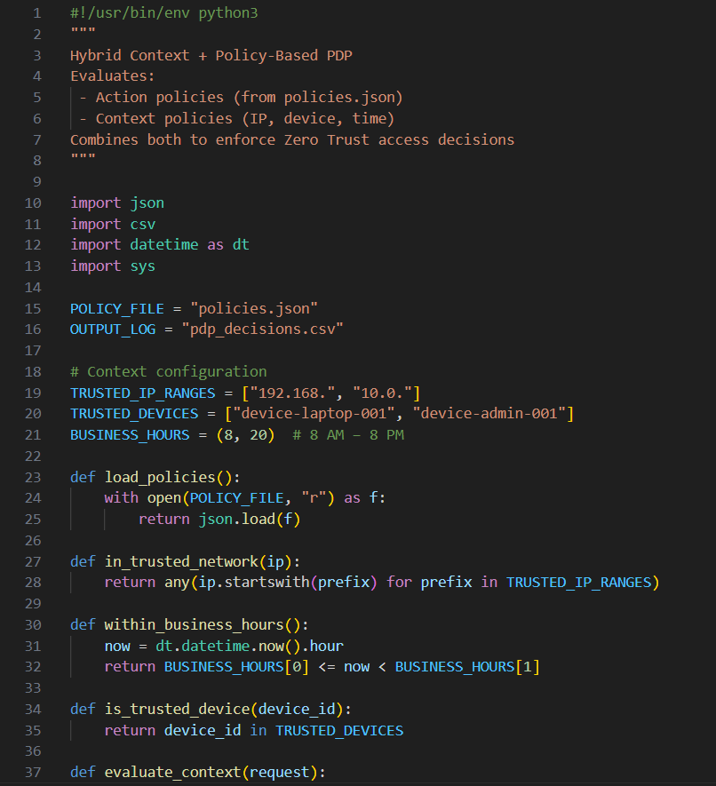
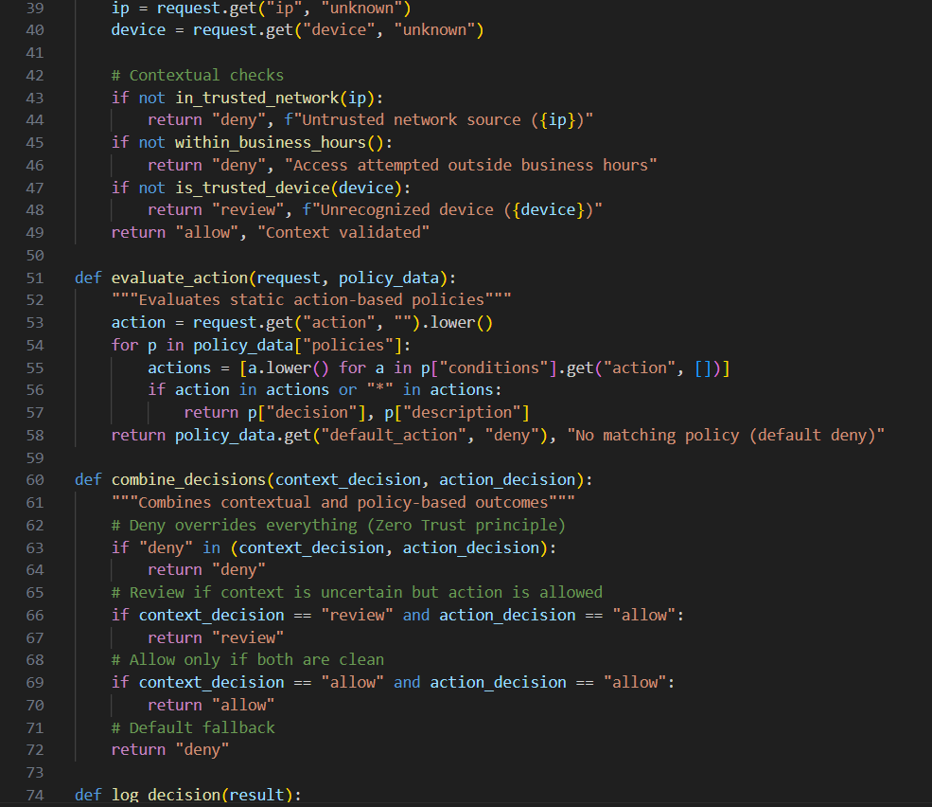
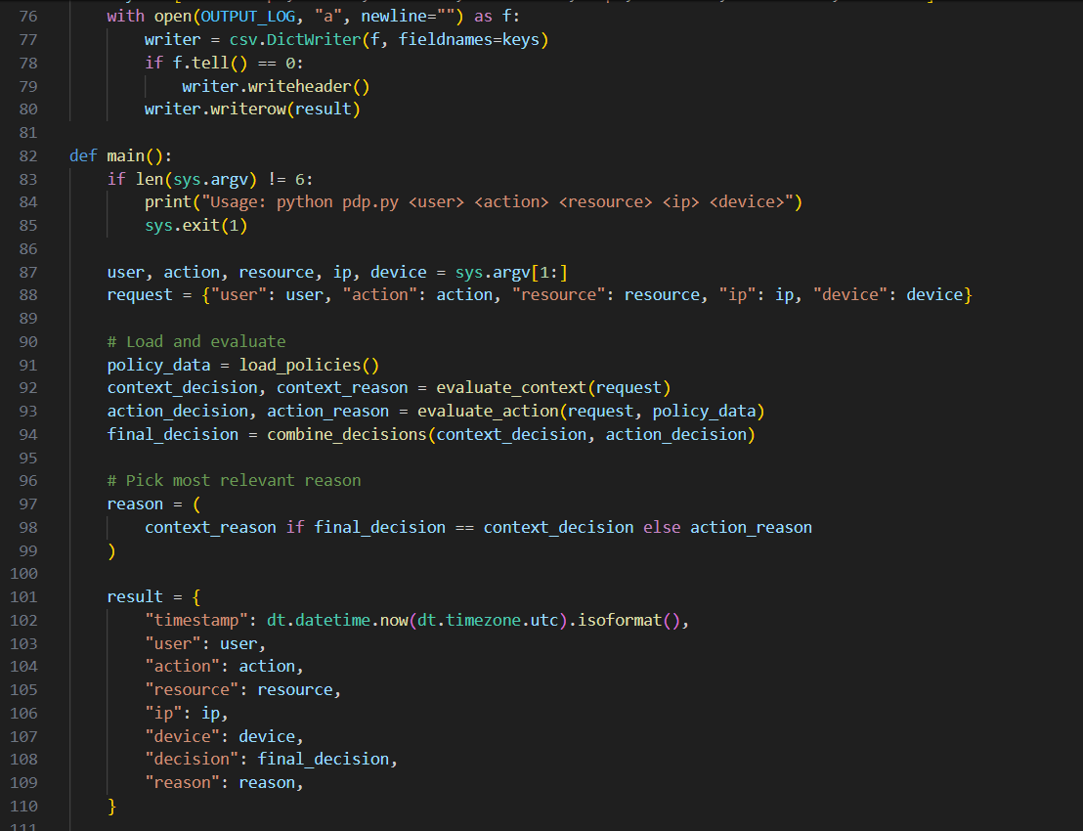

Output:
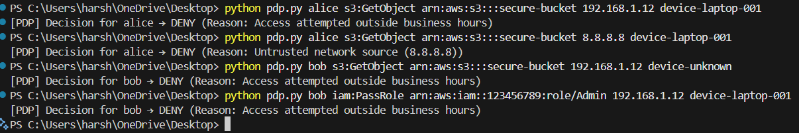
Command 1: Allowed Context + Allowed Policy
Command 2: Untrusted IP, even if Action is Safe
Command 3: Unknown Device, Safe Action
Command 4: Denied Action (iam:PassRole)

Logs:
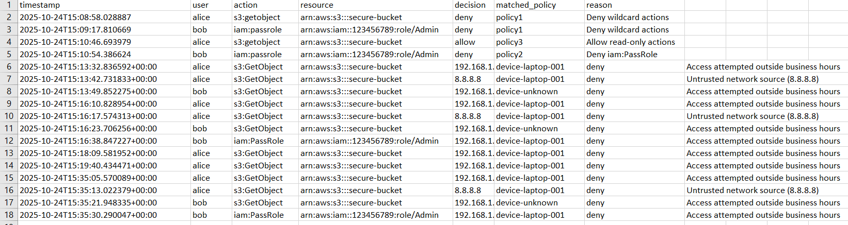

Policy Enforcement Point (PEP) Implementation

- The PEP (Policy Enforcement Point) is the gatekeeper — every request to access a resource passes through it.
- It forwards the access request (user, action, resource, IP, device, etc.) to the PDP (Policy Decision Point).
- The PDP evaluates the request based on policies, context, and risk, and returns either ALLOW or DENY.
- The PEP enforces that decision — allowing or blocking the request.

Code:
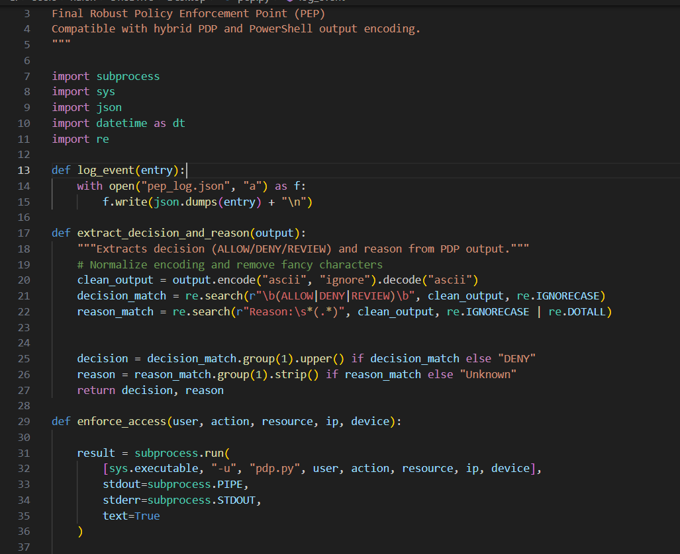
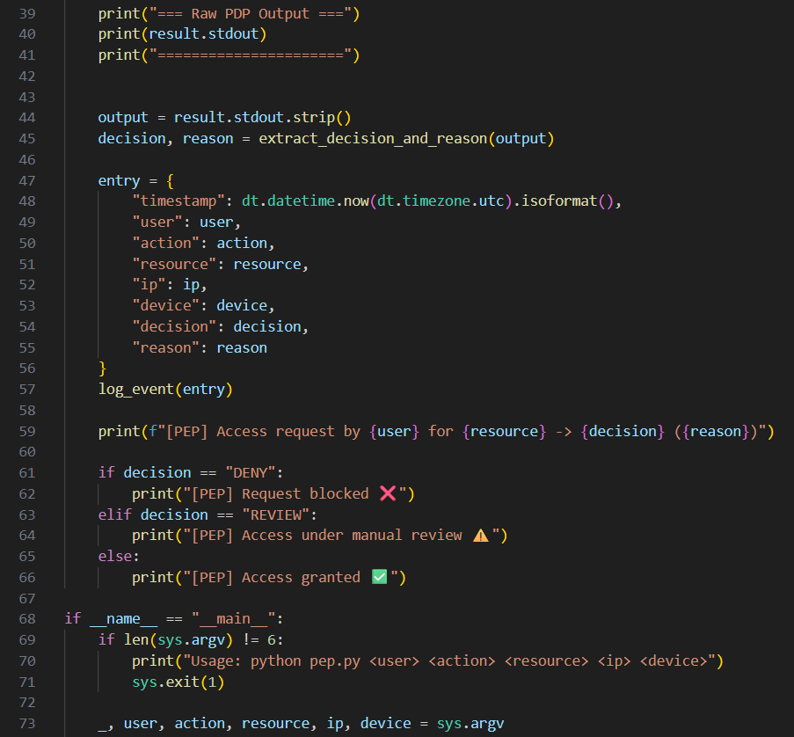

Output:
Allow Example:
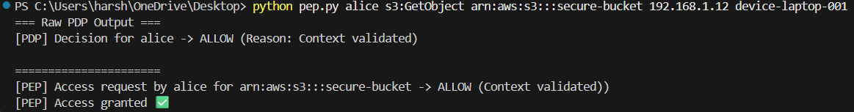

Deny Example:
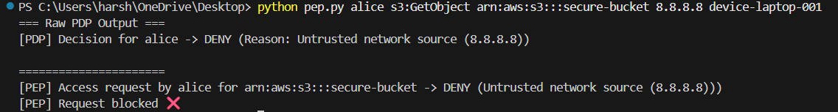

Auto Remediation Module

Feature | Description | Benefit
Multi-cloud support | AWS, Azure, GCP | Cross-cloud remediation
Policy-driven automation | Triggered by PEP/PDP decisions | Reduces manual effort
Action logging | Stores timestamped logs in JSON | Auditability & traceability
Flexible actions | Auto-remediation + review notifications | Combines automation & oversight
Lightweight & extensible | Modular Python code | Easy to scale and maintain
Context-aware | Includes user/resource/cloud/reason | Better incident analysis
Real-time enforcement | Triggered immediately after PEP | Mitigates risks quickly
Audit-friendly output | JSON logs | Integrates with SOC/SIEM

Code:
Arm.py
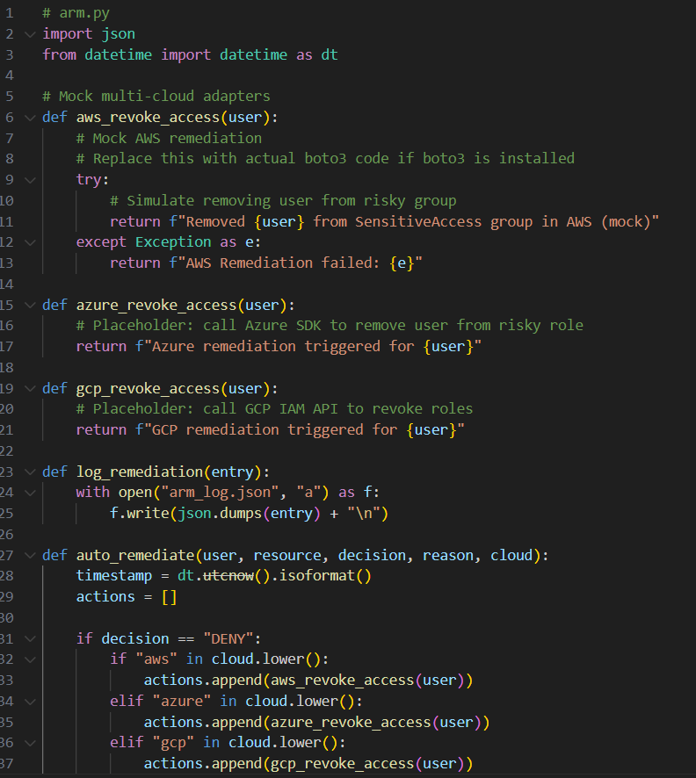
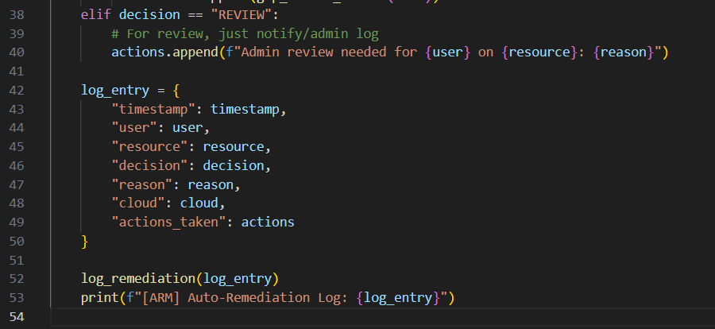
Modification in pep.py to integrate auto remediation when PEP is run.
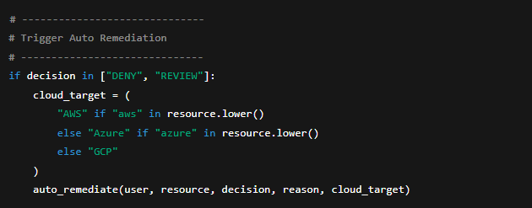
Result:
Allow (No remediation required)
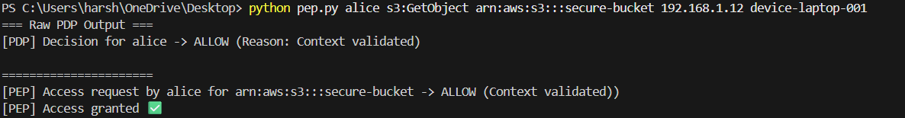
Deny (With remediation)
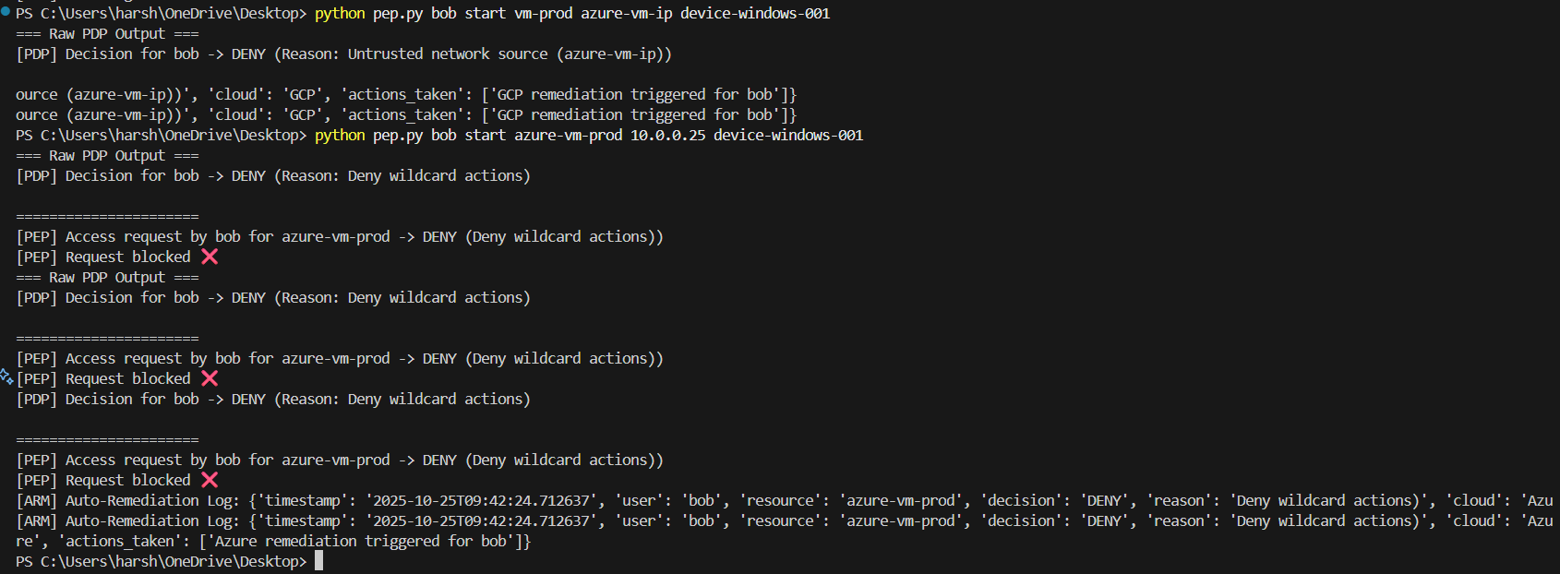

Monitoring and Logging Module

Centralized Logging
- Every event in the framework (PEP decisions, ARM actions, etc.) is logged as a structured JSON entry.
- Example fields logged:
  - timestamp → when the event occurred
  - module → which component generated the event (PEP, ARM, etc.)
  - event_type → type of event (ACCESS_REQUEST, REMEDIATION, etc.)
  - user, resource, cloud, decision, reason → context of the event
  - actions_taken → for remediations
- Logs are stored in a dedicated file, e.g., logs/ztmc_framework_log.json.
- Optional: separate log files per module if needed.
Metrics Aggregation
- The module maintains counters for key metrics, including:
  - Total access requests (total_access_requests)
  - Counts per decision type (allow_count, deny_count, review_count)
  - Total remediations executed (total_remediations)
  - Breakdown per cloud (AWS, Azure, GCP)
  - Breakdown per event type (events_by_type)
- Metrics are persisted in a separate file, e.g., logs/ztmc_framework_metrics.json.
Thread-Safe Updates
- Uses a lock to ensure metrics are updated safely if multiple modules write at the same time.
- Ensures logs and metrics are consistent and accurate.
Code:
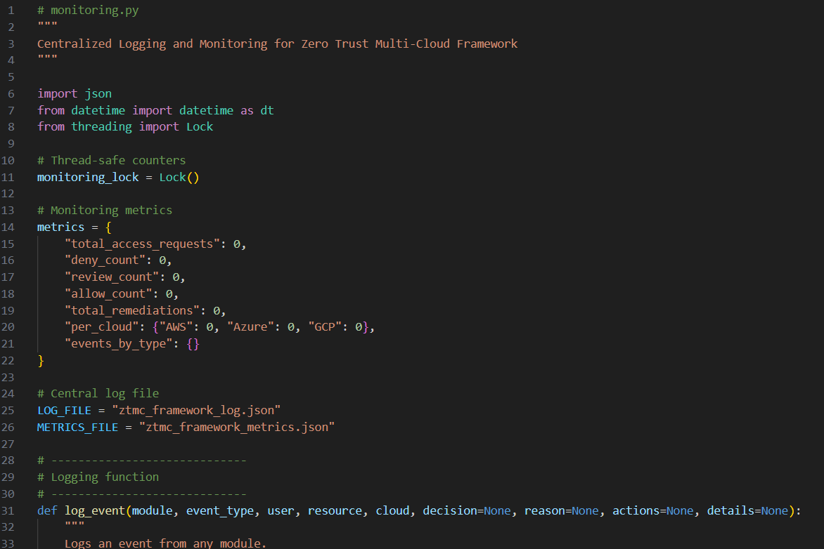
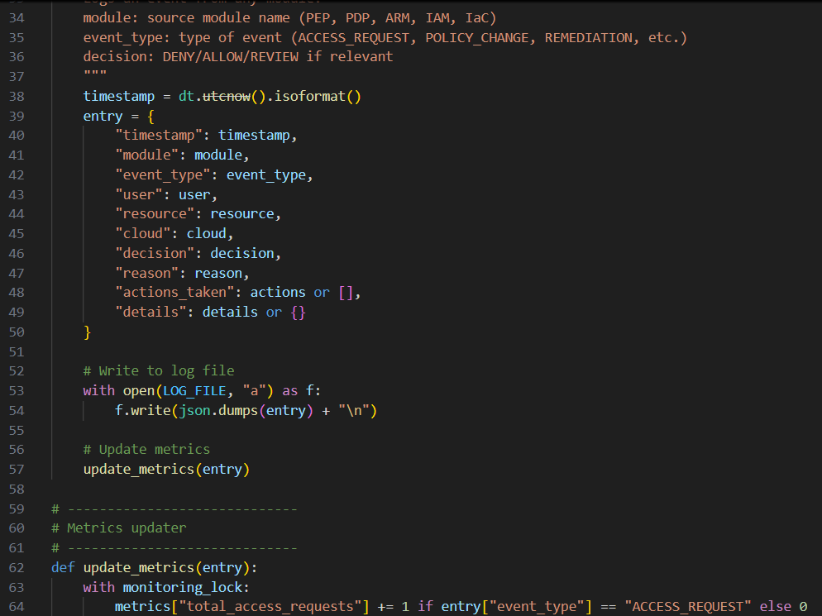
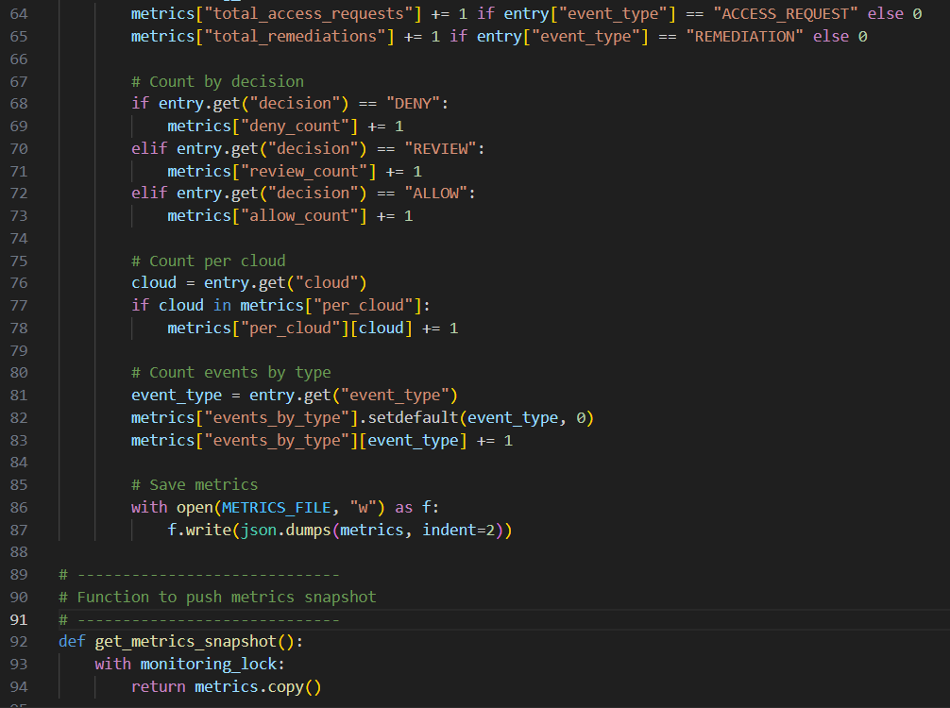

Output:
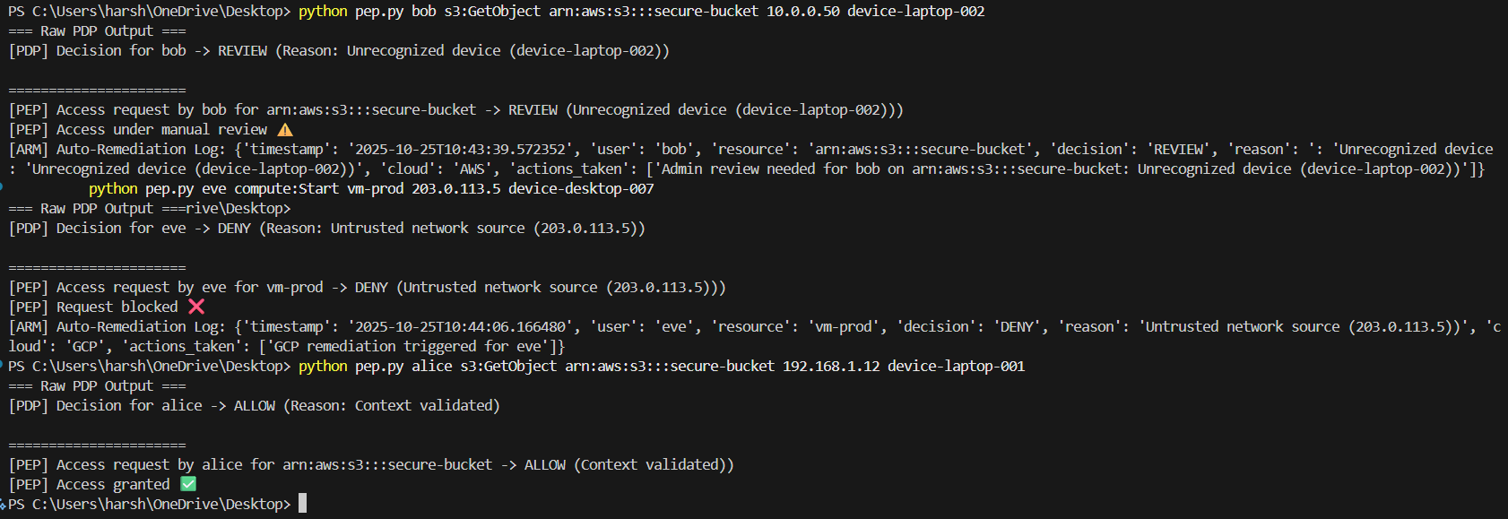
Logs (ztmc_framework_log.json):
Metrics (ztmc_framework_metrics.json):
